[](https://onlinelibrary.wiley.com/journal/13652559)

Original Article

**GATA3 expression in primary vulvar Paget disease: a potential pitfall leading to misdiagnosis of pagetoid urothelial intraepithelial neoplasia**

**Correction(s) for this article**

[Diogo Morbeck](https://onlinelibrary.wiley.com/action/doSearch?ContribAuthorStored=Morbeck%2C+Diogo), [Aline C Tregnago](https://onlinelibrary.wiley.com/action/doSearch?ContribAuthorStored=Tregnago%2C+Aline+C), [Glauco Baiocchi Netto](https://onlinelibrary.wiley.com/action/doSearch?ContribAuthorStored=Netto%2C+Glauco+Baiocchi), [Carlos Sacomani](https://onlinelibrary.wiley.com/action/doSearch?ContribAuthorStored=Sacomani%2C+Carlos), [Patricia M Peresi](https://onlinelibrary.wiley.com/action/doSearch?ContribAuthorStored=Peresi%2C+Patricia+M) , [Cynthia T Osório](https://onlinelibrary.wiley.com/action/doSearch?ContribAuthorStored=Os%C3%B3rio%2C+Cynthia+T), [Luciana Schutz](https://onlinelibrary.wiley.com/action/doSearch?ContribAuthorStored=Schutz%2C+Luciana), [Stephania M Bezerra](https://onlinelibrary.wiley.com/action/doSearch?ContribAuthorStored=Bezerra%2C+Stephania+M), [Louise de Brot](https://onlinelibrary.wiley.com/action/doSearch?ContribAuthorStored=Brot%2C+Louise), [Isabela W Cunha](https://onlinelibrary.wiley.com/action/doSearch?ContribAuthorStored=Cunha%2C+Isabela+W)[**... See fewer authors**](https://onlinelibrary.wiley.com/doi/abs/10.1111/his.13086)

First published: 16 September 2016

[**https://doi.org/10.1111/his.13086**](https://doi.org/10.1111/his.13086)

[**Read the full text**](https://onlinelibrary.wiley.com/doi/full/10.1111/his.13086)

[[ePDF](https://onlinelibrary.wiley.com/doi/epdf/10.1111/his.13086)PDF](https://onlinelibrary.wiley.com/doi/epdf/10.1111/his.13086)

[TOOLS](https://onlinelibrary.wiley.com/doi/abs/10.1111/his.13086)

[SHARE](https://onlinelibrary.wiley.com/doi/abs/10.1111/his.13086)

Abstract

Aims

GATA3 has been reported as a specific urothelial marker among organs in the pelvic region, and has been classified as highly sensitive and specific for urothelial and breast carcinomas. Our aim was to verify GATA3 expression in extramammary Paget disease, and to determine whether it can be use to differentiate primary vulvar Paget disease from pagetoid urothelial intraepithelial neoplasia (PUIN). We also analysed HER2 protein expression and *HER2* gene amplification and their roles as prognostic factors in extramammary Paget disease.

Methods and results

We analysed GATA3 and HER2 expression in 11 primary vulvar Paget disease cases and two PUIN cases. All cases showed nuclear expression of GATA3. Of 13 cases, five were equivocal for HER2 expression (score 2+) and one was positive (3+). Fluorescence *in‐situ*hybridization results showed amplification in two of these six cases. Both *HER2*‐amplified cases were invasive.

Conclusion

GATA3 was positive in all extramammary Paget disease cases tested (13 cases), and it has no value for differentiating between primary and secondary vulvar Paget disease from the urological tract. *HER2* amplification might confer an aggressive and invasive pattern in primary vulvar Paget disease, as both amplified cases showed an invasive pattern.

[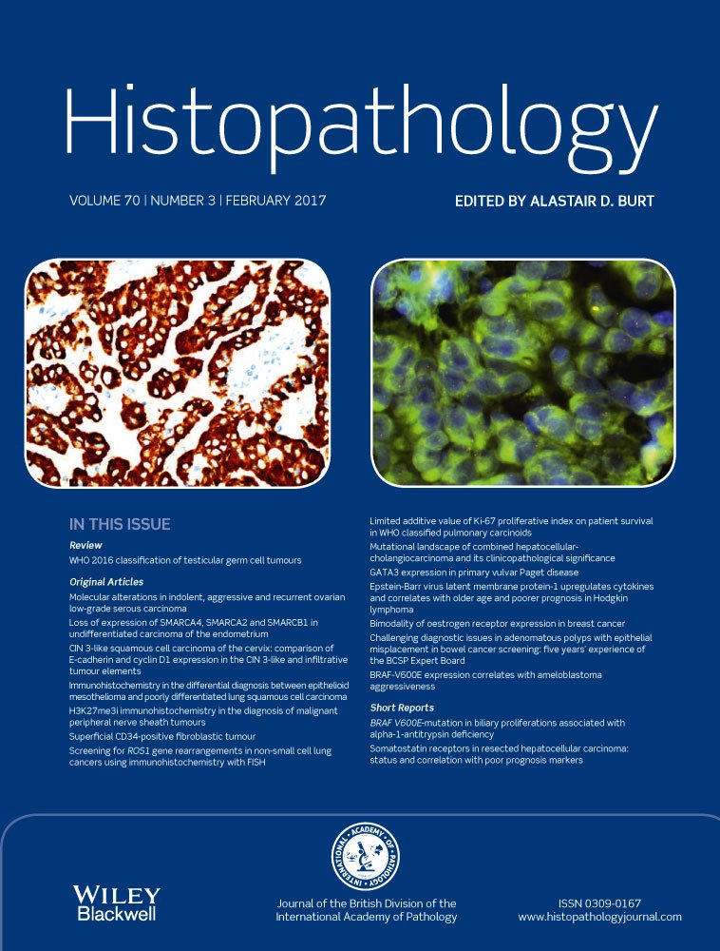](https://onlinelibrary.wiley.com/toc/13652559/2017/70/3)

[**Volume70, Issue3**](https://onlinelibrary.wiley.com/toc/13652559/2017/70/3)

February 2017

Pages 435-441